Stack for Train Line

**Figure: Diagram of Train Ticket Reservation**

Train Ticket

Reservation

Destination

Train

Source

Time

Train Info

Queue for Train Line

**Abstract:**

Train Ticket Reservation System is a complex online distributed transaction application. The salient features of the software include allowing user from anywhere to do a booking for a train journey in anytime from anywhere to anywhere. The travelers can book a ticket at a click of a mouse and save their time and money.

**Introduction:**

In this project we tried to make an online train ticket reservation system. It basically concerned with the reservation of railway tickets to the passengers. The need of this system arose because we have a large railway network system in our country and everyday a lot of people travel by train so it not possible to handle such a large system manually. By computerizing it, it became possible to overcome the limitation and make the system operations more efficient. The handling of data and records for such vest system is a very complex but when the system is computerized the task become much easier.

**Objective:**

* Reduce paperwork.
* Reduce the possibility of making mistake.
* Making ticket reservation easier.
* Enhancing the efficiency and diversification of services activities.
* Reducing the complexity of the existing system.

**Scope of the software:**

At first the users have to input the train name, source, destination and departure time of the Train. This data will be added to the backed as the train information. Next, the user will be able to input data regarding the passenger number and destination and the program will search for train in that destination and reply accordingly. At last the data of the trains will be shown as a Stack display.

**Requirement analysis:**

* PC with GNU GCC Compiler.
* C/C++ IDE.

**System requirement:**

CodeBlocks.

**Screenshots:**

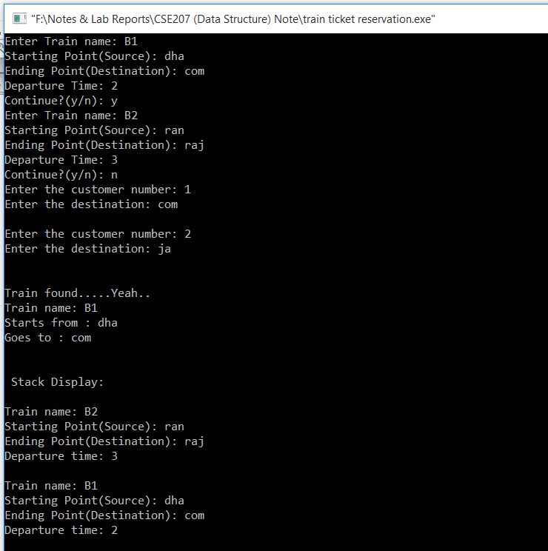

**Future plan:**

In future we are planning to add more features to this system. We will add functions regarding the checking of train seats and implement file to store the data permanently in the memory. We will also add the function to print the passenger ticket.

**Conclusion:**

We tried our best to make the system error free and make it user friendly so that people can easily plan their journey comfortably as the task of booking a ticket is much easier and hassle free.